To
From
Date
Subject: Final Prototype Summary
The project is to develop a robot which can move and balance itself without taking any support and must be stable over the rough terrains, for this purpose a two wheeler robot has decided to select and it will move in all direction without falling down. The two wheeler robot final prototype has developed and it has shown below
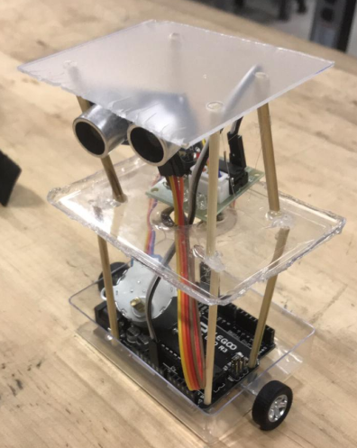
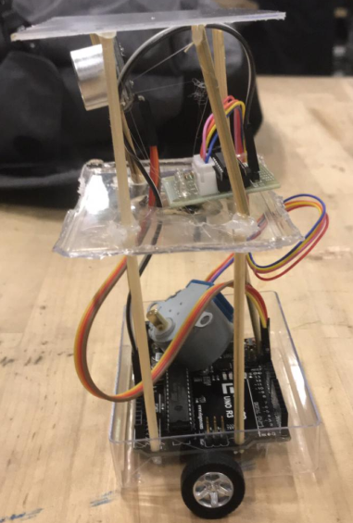
Figure 1: Final Prototype
The device has two upper stories and a ground story. All these stories have made with the help of a transparent plastic glass. The lowest portion contains the ELEGOO Arduino microcontroller PCB, which is controlling all the parts of the robot. There are two wheels connected under the ground plastic and these wheels have connected through the rotating shaft. These wheels have not connected with the motor yet in the prototype but in the final design, these wheels will connect with the motors through this shaft and motor will run to move the wheels. The device standing structure has built with the help of wooden sticks and stuck on the plastic using the glue as shown in the figure 1. All the jumper wires have connected through the connectors from the Arduino controller to the sonar sensors. These sensors have connected at the top of the robot and fixed on the position by tighten with the sticks.
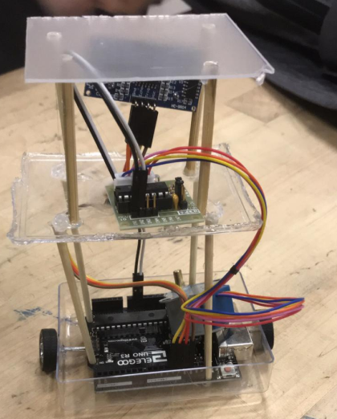
Figure 2: Jumper wires and back side view
There are two sonars connecting together in the front side of the robot. These sonars have connected directly to the Arduino board.
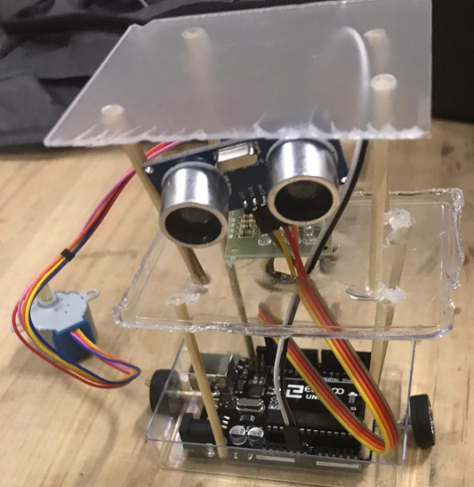
Figure 3: Sonars
There is a motor controller chip present in the middle story of the robot and this motor controller is connecting with the main controller and also a motor has connected with it just to show how the motor will operate from the Arduino. The motor controller is connecting with the Arduino board as well and all the controlling instructions are going from the Arduino to the motor controller and this motor controller will control the motor, either increase or decrease the speed, start or stop the motor, move the motor in forward direction or backward direction. A single motor has shown for now in the prototype and the shaft of motor is rotating as well currently in the prototype.
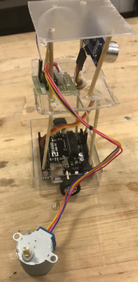
Figure 4: Motors
The sonars are working; the lights have attached to the prototype which blinks when the power supplies to the robot. As this a prototype just to test the components are working and the design is working or not. So from this prototype, it is clear that all the components like Arduino board, motor controller board, sonars, motors, wheels, and jumper wires, all are working and can implement the final design.

